Supplementary material for

A K isotope perspective on influences of saline springs on river water chemistry
Chen Li ª, HongWei Yin ª, ShiLei Li ^{a,b*}, LaiFeng Li ^{c}, ZhongYing Miao^{d}, YiDe Liu ª, WeiQiang Li ª

ª School of Earth Sciences and Engineering, Nanjing University, Nanjing 210023, China;
^{b} Key Laboratory of Surficial Geochemistry, Ministry of Education, Nanjing University, Nanjing 210023, China;
^{c} School of Geography and Ocean Sciences, Nanjing University, Nanjing 210023, China
^{d} MNR Key Laboratory of Saline Lake Resources and Environments, Institute of Mineral Resources, Chinese Academy of Geological Sciences, Beijing 100037, PR China
* E-mail:shileili@nju.edu.cn

Text S1. Evaluation of anthropogenic influence on riverine δ⁴¹K
To further assess the potential impact of anthropogenic inputs, δ⁴¹K values of river waters are compared with NO₃/K ratios (Fig. S1). Nitrate is widely used as an indicator of anthropogenic contamination, particularly from agricultural fertilizers and domestic wastewater. A representative fertilizer endmember is also shown, with NO₃/K = 17 (based on regional agricultural statistics from the Yunnan Statistical Yearbook) and δ⁴¹K values ranging from -0.16‰ to 0.51‰ (Qu er al., 2023). As shown in Fig. S1, river water samples do not exhibit any systematic correlation between δ⁴¹K and NO₃/K, and their distribution does not align with the expected mixing trend toward the fertilizer endmember. Instead, river samples remain clearly distinct from the anthropogenic field.This mismatch indicates that anthropogenic inputs do not significantly influence K isotopic compositions. Therefore, variations in δ⁴¹K primarily reflect natural geochemical processes rather than human activities
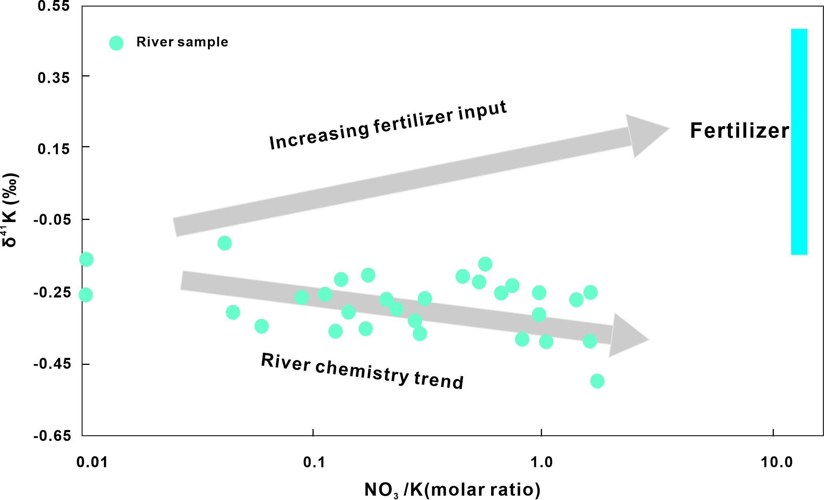
Fig. S1. Relationship between δ⁴¹K and NO₃/K ratios in river waters and comparison with a representative fertilizer endmember..

Text S2. Mass-balance correction for evaporite and carbonate contributions
To correct for the potential contribution of evaporite- and carbonate-derived potassium to riverine δ⁴¹K, we apply a two-component mass-balance model:
F δ⁴¹K_{endmember} + (1-F) δ⁴¹K_{cor} = δ⁴¹K_{riv} (m1)
where F is the fractional contribution of the evaporite or carbonate endmember, δ⁴¹K_{endmember} is the isotopic composition of the minor source, δ⁴¹K_{cor} represents the corrected silicate-derived component, and δ⁴¹K_{riv} is the measured river water composition.
Rearranging:
Δδ⁴¹K = δ⁴¹K_{riv} - δ⁴¹K_{cor} = F/(1-F)(δ⁴¹K_{endmember} - δ⁴¹K_{riv} ) (m2)
This expression quantifies the magnitude of isotopic correction required to remove the contribution of minor endmembers. Using maximum estimated contributions of F<0.03 for evaporites and F<0.01 for carbonates, together with reported δ⁴¹K ranges (evaporites: −0.12‰ to +0.20‰; Morgan et al., 2014; Wang et al., 2020; carbonates: −0.28‰ to −0.05‰; Li et al., 2025), the resulting K isotopic offest is <0.02‰.
This magnitude is negligible relative to analytical uncertainty and the observed variability in riverine δ⁴¹K, indicating that correction for evaporite and carbonate inputs does not significantly alter the isotopic interpretation.

Text S3. Spatial variation of Cl/K ratios across the Jinggu catchment
To further evaluate the role of saline spring inputs, Cl/K ratios of river waters were plotted against longitude (Fig. S2). The results show a clear spatial separation: rivers located in western catchments consistently display low Cl/K ratios, whereas rivers in eastern catchments exhibit significantly elevated Cl/K values.
This spatial pattern correlates with the distribution of saline springs, which are restricted to the eastern part of the study area. The absence of elevated Cl/K ratios in western rivers indicates that shallow evaporite dissolution is not a dominant or widespread process across the catchment. Instead, high Cl/K signatures are spatially associated with saline spring occurrence, supporting the interpretation that these signatures arise from localized inputs of deep, evaporite-influenced fluids.
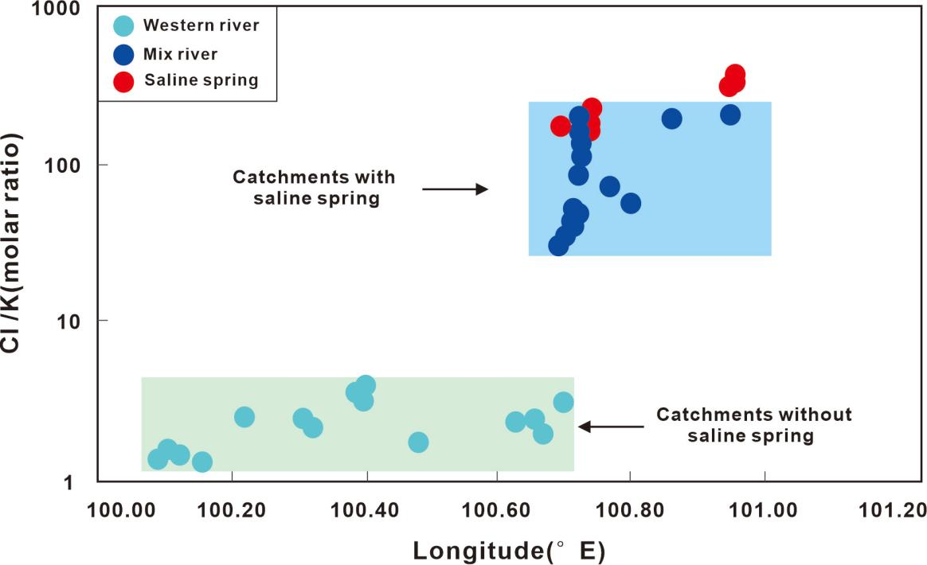
Fig. S2. Spatial variation of Cl/K ratios along longitude in the Jinggu catchment

Text S4. Derivation of binary mixing relationships in Cl/K versus 1/K space
To better constrain the origin of dissolved K and Cl in river waters, we evaluate binary mixing relationships between a river endmember (r) and a saline spring endmember (h) in Cl/K versus 1/K space. A full derivation is provided below.
2.1 Definition of variables
Q_{r、}Q_{h} | water fluxes of river and saline endmembers
f | fraction of saline spring water，f = Q_{h}/(Qr+Q_{h})
K_{r、}K_{h} | K concentrations of river and saline endmembers，K_{h} = bK_{r}
b | relative enrichment factor of K in saline water
A | Cl/K ratio of river endmember，A = (Cl/K)_{r}
H | Cl/K ratio of saline endmember，H = (Cl/K)_{h}
x | Cl/K ratio of mixed water，x = (Cl/K)_{m}
K_{m} | K concentration in the mixed water
Cl_{m} | Cl concentration in the mixed water

The following derivation describes binary mixing between a river water endmember (r) and a saline spring endmember (h).
The saline spring fraction is defined as:
f = Q_{h} / (Q_{r} + Q_{h}) (m3)
The fraction of river water is therefore 1 – f. We use Kr and A to represent the K concentration (Kr) and Cl/K ratio of the river endmember, respectively:
A = (Cl/K)_{r} (m4)
Thus, the Cl concentration of the river endmember is:
Cl_{r} = A K_{r} (m5)
The K concentration of the saline endmember is assumed to be b times that of the river endmember:
K_{h} = b K_{r} (m6)
The Cl/K ratio of the saline endmember is:
H = (Cl/K)_{h} (m7)
Thus, the Cl concentration of the saline endmember is:
Cl_{h} = H K_{h} = H b K_{r} (m8)
The mixed Cl/K ratio is defined as:
x = (Cl/K)_{m} (m9)
The mixed K concentration is given by:
K_{m} = (1 - f)K_{r} + fK_{h} (m10)
Substituting K_{h} = bK_{r}：
K_{m} = (1 - f)K_{r} + f b K_{r} (m11)
This shows the relationship between the concentration of K after mixing and the ratio f of the salt spring water volume.
Mixing of Cl concentration
Similarly, the mixed Cl concentration is:
Cl_{m} = (1 - f)Cl_{r} + fCl_{h} (m12)
Substituting Cl_{r} = AK_{r} and Cl_{h} = HbK_{r}：
Cl_{m} = (1 - f)AK_{r} + fHbK_{r} (m13)
Cl_{m} = K_{r}[A(1 - f) + Hbf] (m14)
The mixed Cl/K ratio is:
x = (Cl/K)_{m} = Cl_{m} / K_{m} (m15)
Substituting the expressions above:
x = {K_{r}[A(1 - f) + Hbf]} / {K_{r}[1 + f(b - 1)]} (m16)
x = [A(1 - f) + Hbf] / [1 + f(b - 1)] (m17)
Thus:
f = (A - x) / [A - Hb + x(b - 1)] (m18)
Substituting into:
K_{m} = K_{r}[1 + f(b - 1)] (m19)
gives:
K_{m} = K_{r} {1 + (b - 1)(A - x) / [A - Hb + x(b - 1)]} (m20)
Thus:
K_{m} / K_{r} = b(A - H) / [A - bH + (b - 1)(Cl/K)_{m}] (m21)
That is:
1/K_{m}= [A - bH + (b - 1)(Cl/K)_{m}]/(K_{r} b(A-H)) (m22)
Let:
y=1/K_{m}, x=(Cl/K)_{m}, (m23)
Then:
y=(A - bH)/((K_{r}b(A-H)) + (b - 1)x/(K_{r} b(A-H) (m24)
The derivation above demonstrates that binary mixing between two endmembers produces a linear relationship in Cl/K versus 1/K space. In this study, these endmembers correspond to (i) a silicate weathering–dominated river water endmember, characterized by low Cl/K and high 1/K, and (ii) a saline spring endmember, characterized by high Cl/K and low 1/K.
The observed data from the Jinggu catchment follow this framework (Fig. 11). Western rivers cluster at low Cl/K and high 1/K values, defining the silicate weathering endmember and indicating negligible influence from saline inputs. In contrast, eastern rivers display a broader range of Cl/K and 1/K values and align along a mixing trend toward saline spring compositions, reflecting progressively increasing contributions of saline-derived solutes. Saline spring samples define the high Cl/K, low 1/K endmember of the system. The systematic shift from western to eastern rivers therefore reflects increasing influence of saline inputs across the catchment. The EK river samples, although offset in conventional concentration plots, follow a distinct but mixing-consistent trajectory in this representation, consistent with mixing between a relatively low-K river endmember and saline waters with high Cl/K ratios.

Text S5. Controls on elevated δ⁴¹K in saline springs
To better constrain the origin of elevated δ⁴¹K values in saline springs, both elemental ratios and isotopic compositions are evaluated. Fig. S3a shows the relationship between Na/K and δ⁴¹K for saline spring samples. A positive trend is observed, indicating progressive fluid evolution during deep groundwater circulation. This trend is consistent with isotopic fractionation during water–rock interaction, where light K isotopes are preferentially incorporated into secondary minerals (e.g., clay minerals), resulting in enrichment of heavy K isotopes in the residual fluid.
In addition, Fig. S3b shows the δ⁴¹K compositions of different reservoirs. K-bearing evaporites display relatively heavy δ⁴¹K values, overlapping with those of saline springs, whereas river waters are systematically lighter. This overlap indicates that evaporite dissolution provides a heavy isotopic endmember to the system.
Therefore, the elevated δ⁴¹K values observed in saline springs can be explained by the combined effects of (i) dissolution of K-bearing evaporites and (ii) isotopic fractionation during prolonged water–rock interaction.
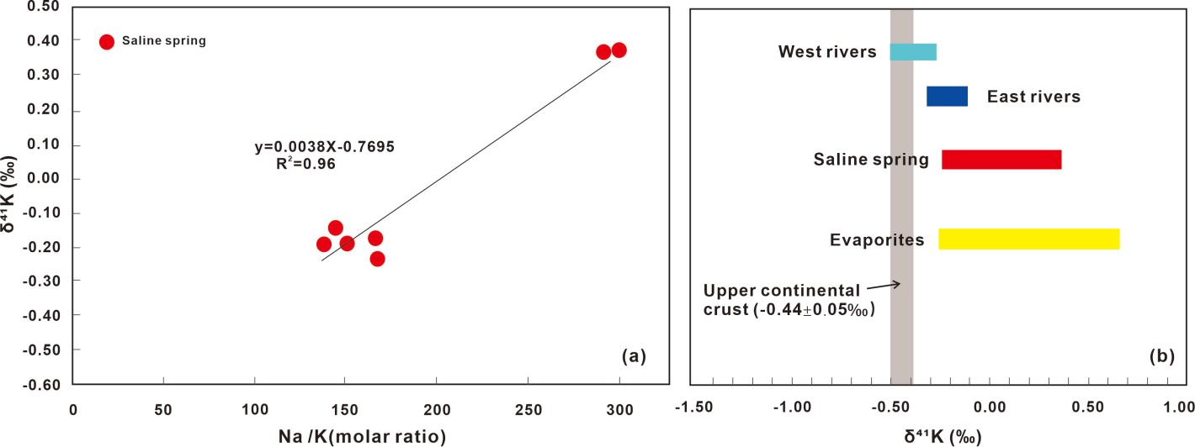
Fig. S3. (a) Relationship between Na/K (molar ratio) and δ⁴¹K for river waters and saline springs. (b) Comparison of δ⁴¹K compositions of river waters, saline springs, and evaporites.

